Create a Directory with the Name Linux Practice. Change to the directory

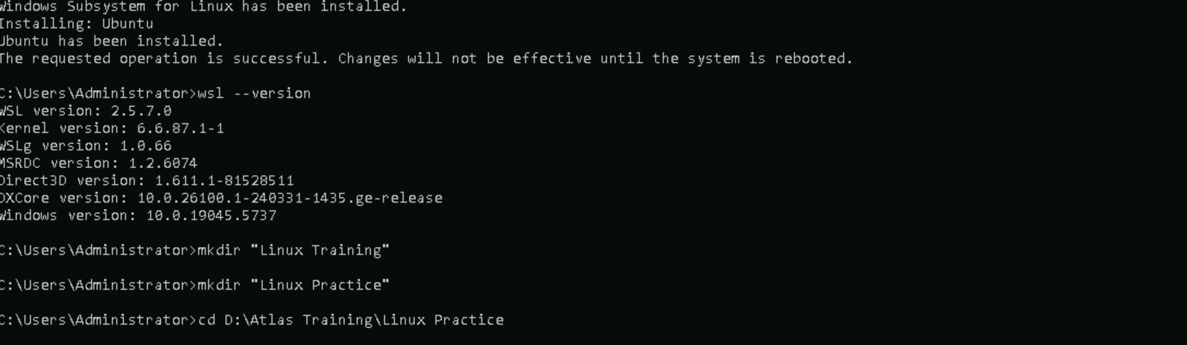

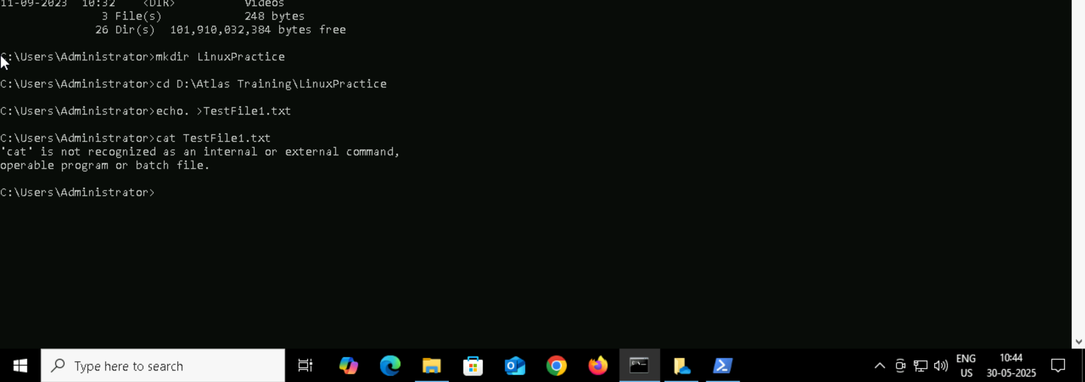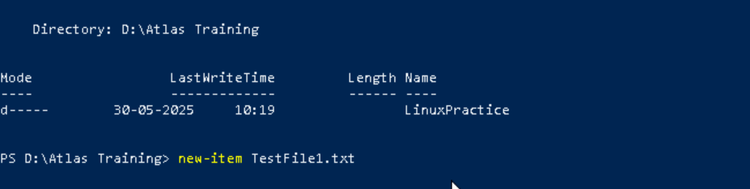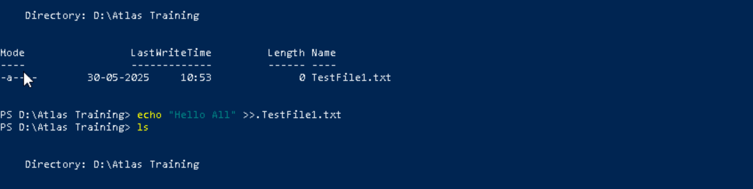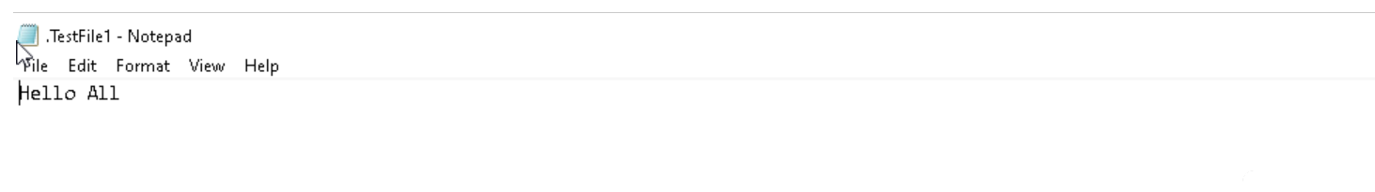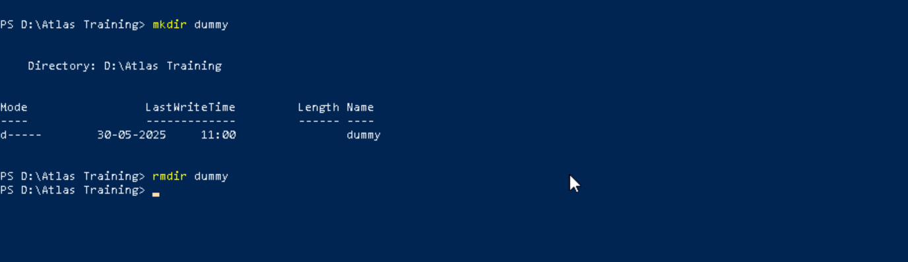

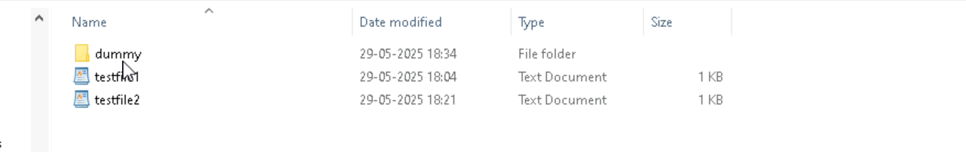

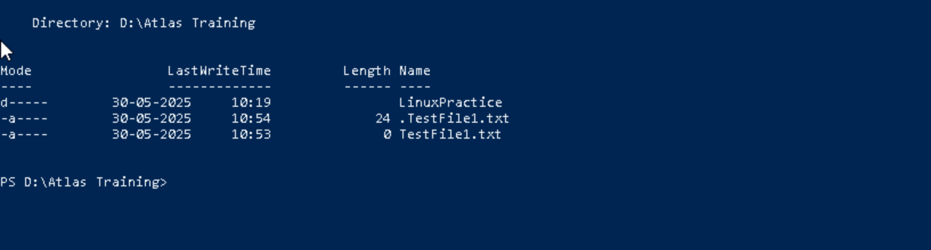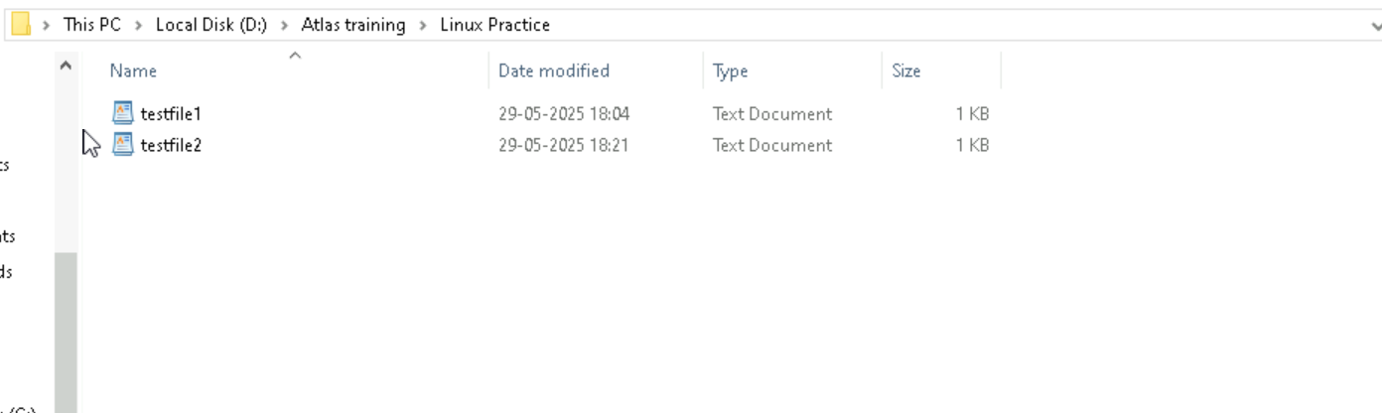

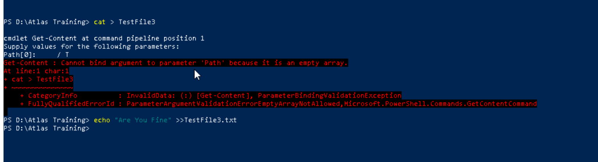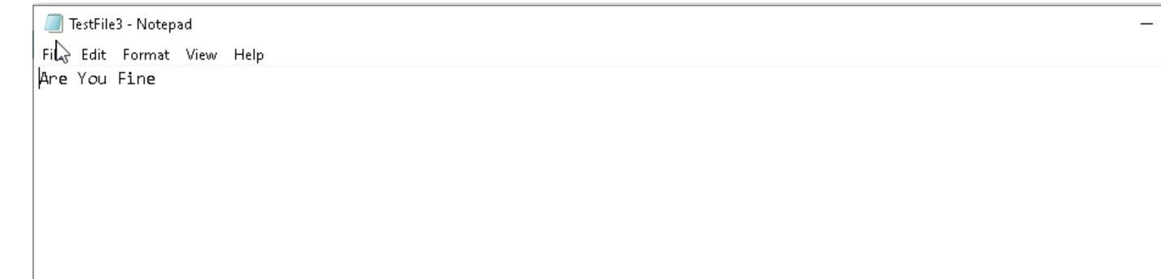

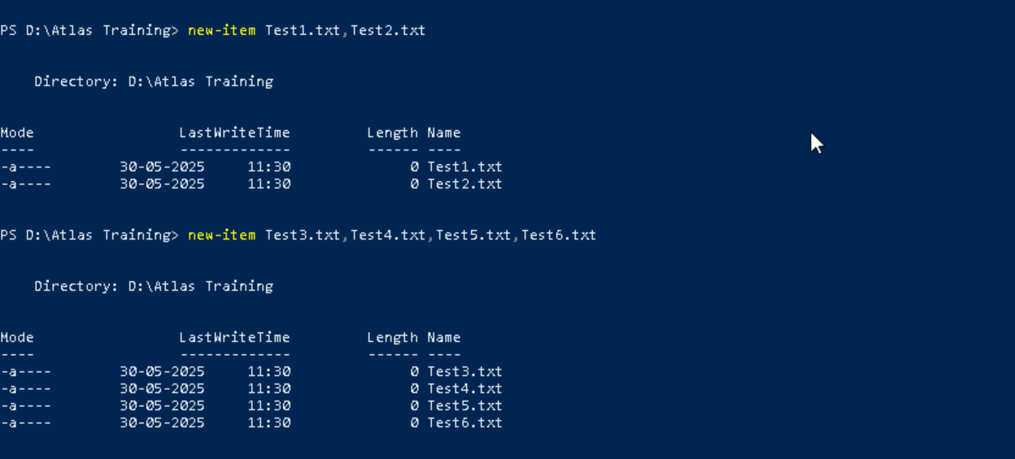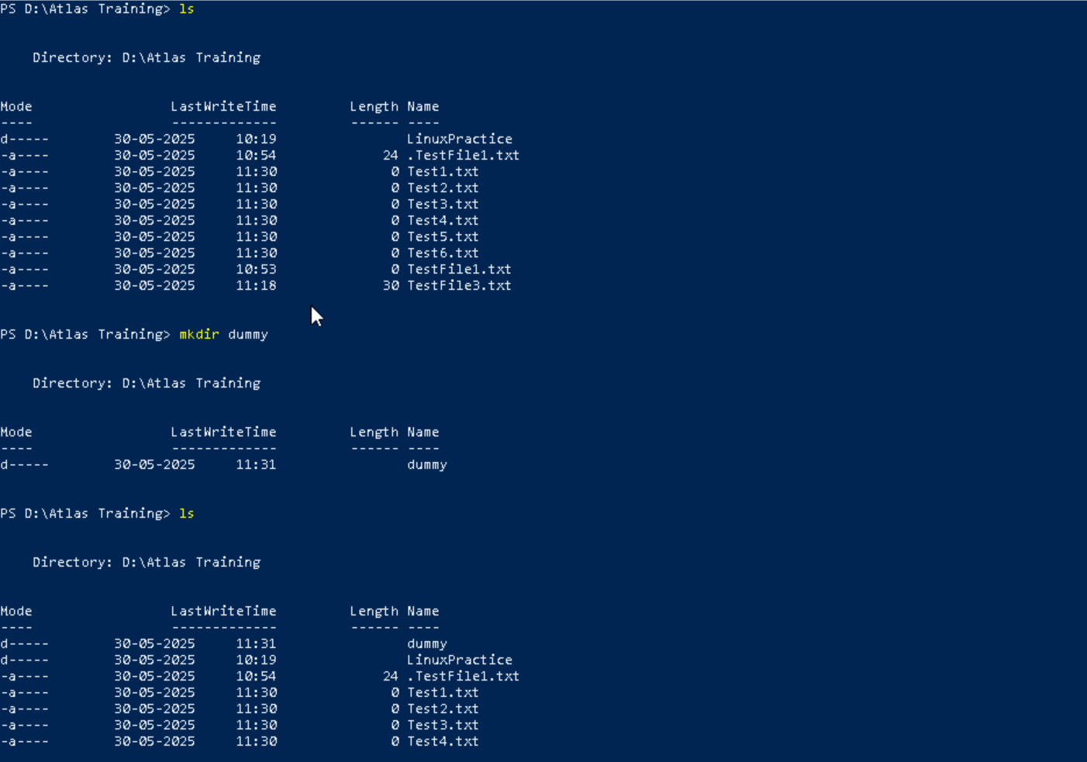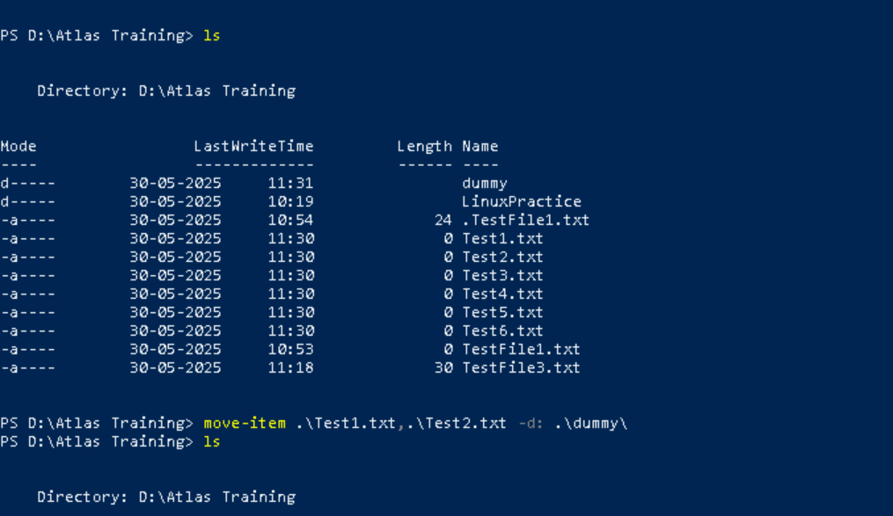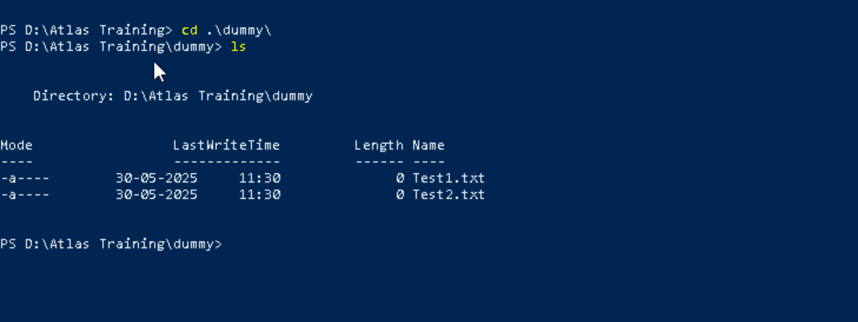

Now use specifically use cat command to create a file and add the dummy text of 2 to 3 paragraphs from the above link Lorem Ipsum.





How to get only the top part of your file..

Hint: use head

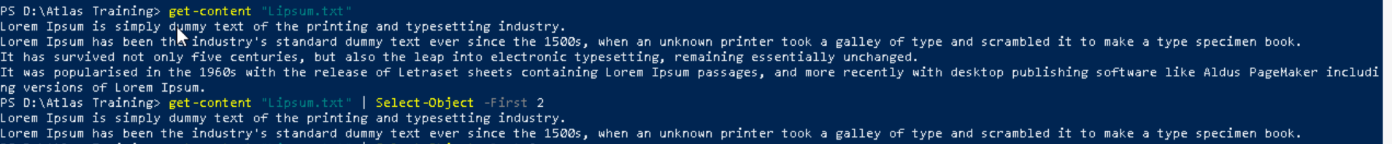

How to get only the last part of your file Hint: use tail



Plz add dummy text of 5 to 6 pages in to the same file

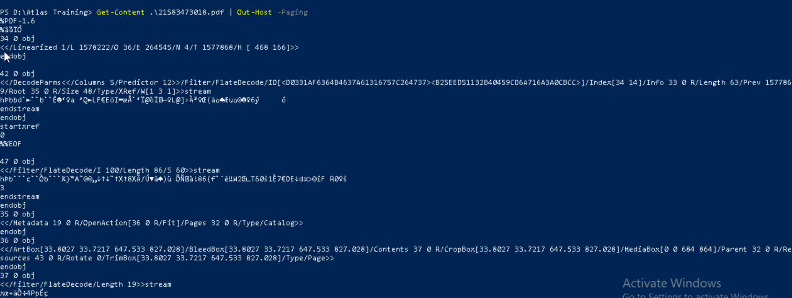

Use more command on the above file and find out the diff between less command and more command.

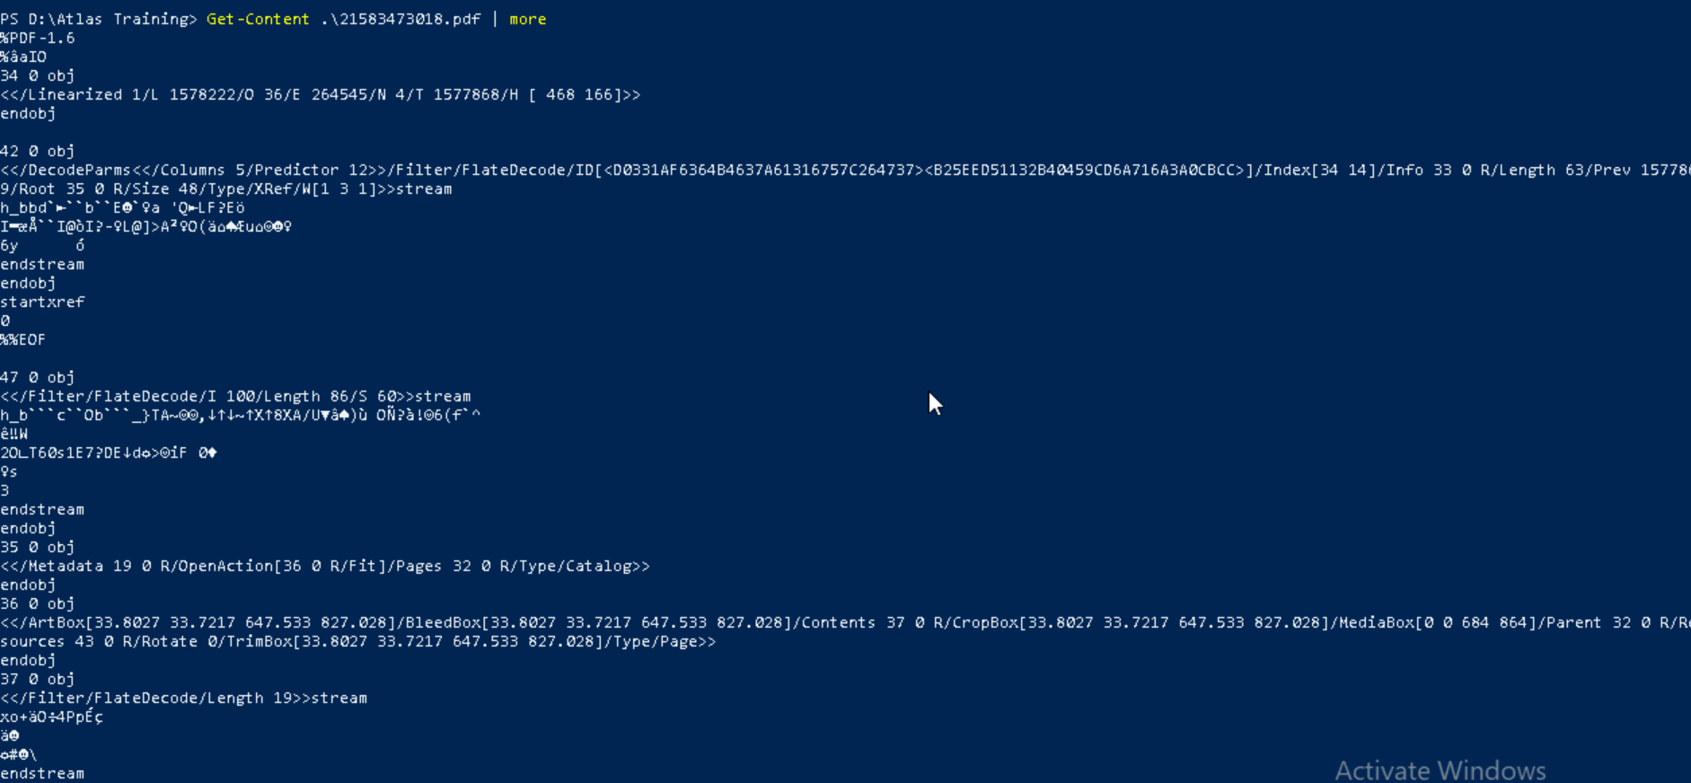

What is diff between ls and ls -l command ..

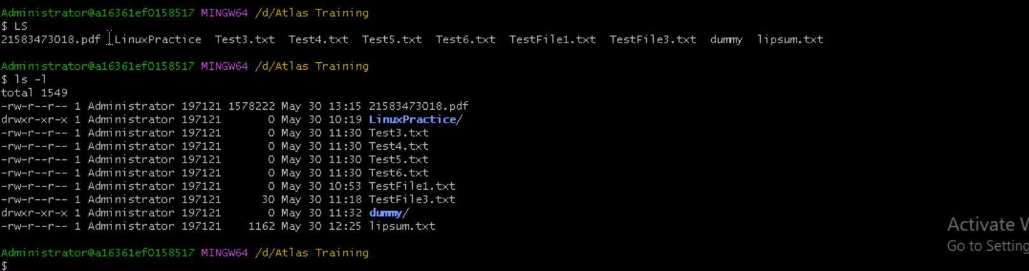

Create  a file using **touch** command , **cat** command and **echo** command

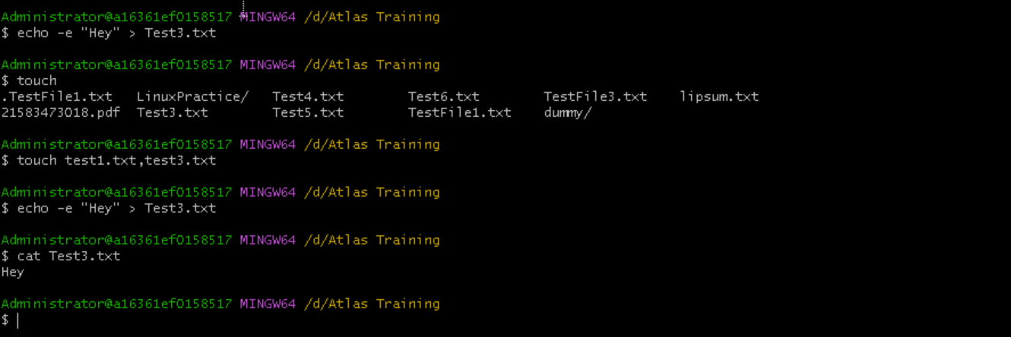

**Touch -** The `touch` command in Linux is a fundamental tool used primarily for creating empty files and updating the timestamps of existing files.

**Cat -** The cat (concatenate) command in Linux displays file contents. It reads one or multiple files and prints their content to the terminal. cat is used to view file contents, combine files, and create new files

**Echo -** The echo command in Linux is used to display text or strings to the standard output (usually the terminal screen).

Can you go back to 1 directory .. at a time  whats the command 

How to know whose user u are working on ?

Hint: use whoami command

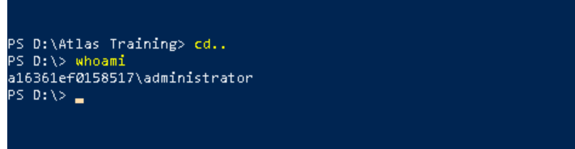

Try to find out who is peeping into your system..

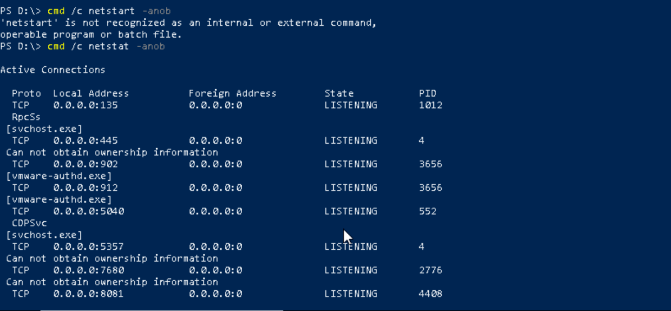

to check how much disk space is consumed..

Hint : use df -h

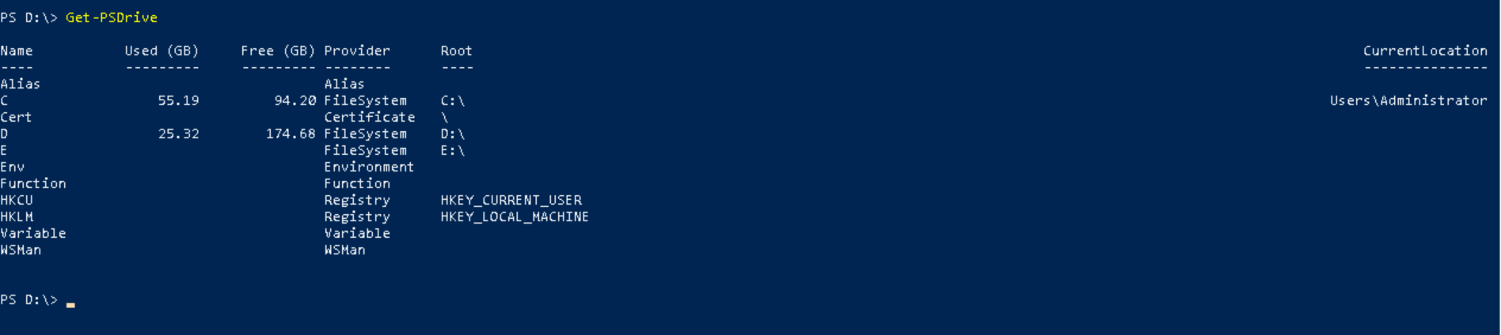

In the **ls -l** listing example, every file line begins with a **d**, **-**, or **l**. These characters indicate the type of the file that's listed.

Can you plz try using the below commands

|  |  |
| --- | --- |
| **Prefix** | **Description** |
| **-** | **Regular file**, such as an ASCII text file, binary executable, or hard link. |
| **b** | **Block special file**. Block input/output device file such as a physical hard drive. |
| **c** | **Character special file**. Raw input/output device file such as a physical hard drive. |
| **d** | **Directory** which contains a listing of other files and directories. |
| **l** | **Symbolic link file**. Links on any regular file. |
| **p** | **Named pipe**. A mechanism for interprocess communications. |
| **s** | **Socket** which is used for interprocess communication. |

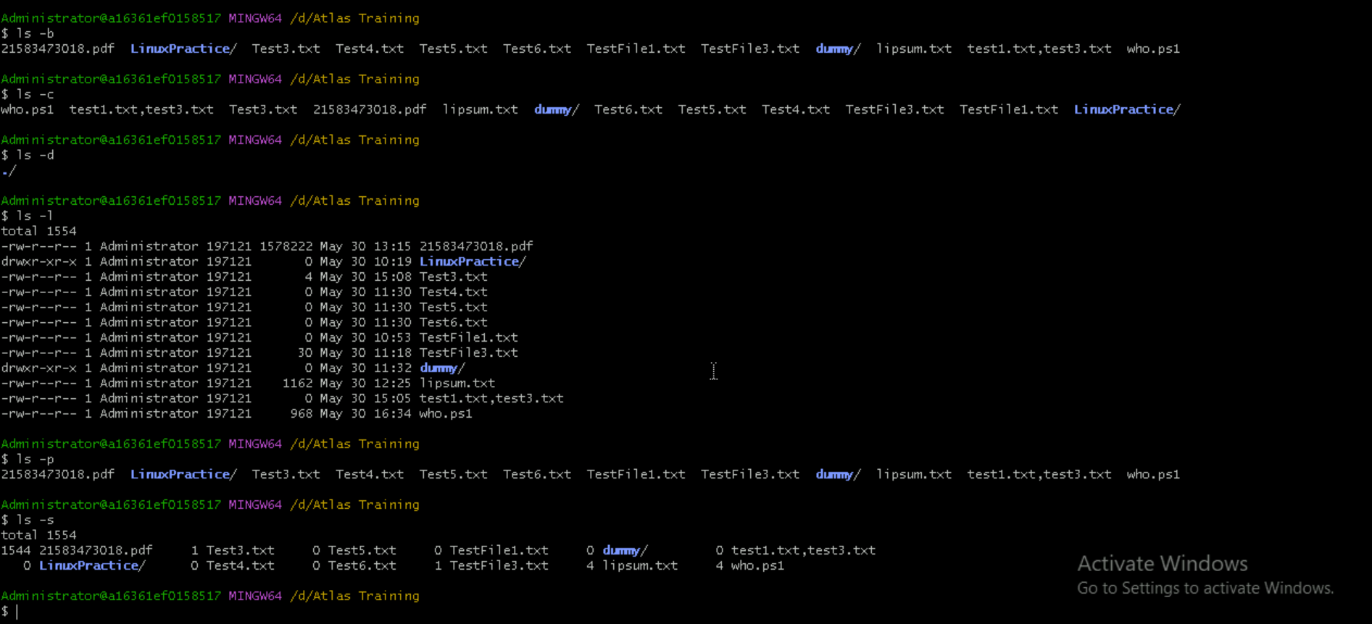

Find the list pf all files ending with .txt

Hint : use * in ls

In Linux all the hidden files starts with . (period)

How to check all the hidden files in Linux Hint : use  ls -a

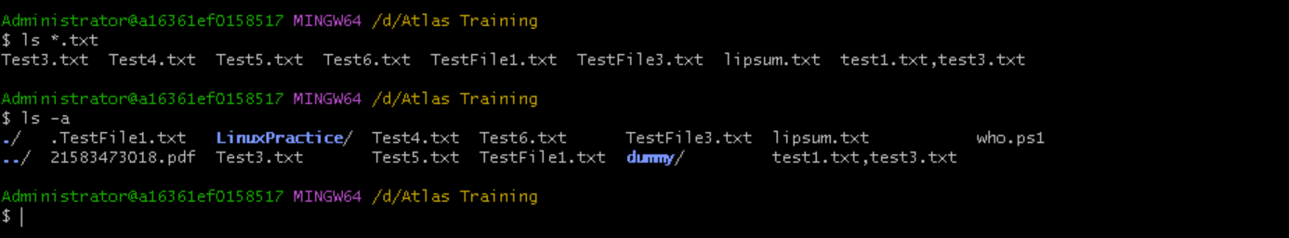

Single dot (.)refers to the current working directory

double dot (..)refers to the parent directory (one level up in the directory hierarchy)

**Create a file using vi editor**

Hint:

Esc is for come out of the edit mode

Press two keys Shift &plus; ZZ together to come out of the file completely (I - to insert)

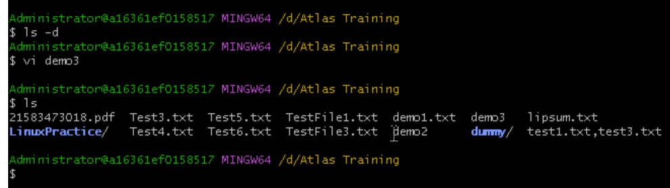

**How to find the no of words in the file**

Hint: use wc

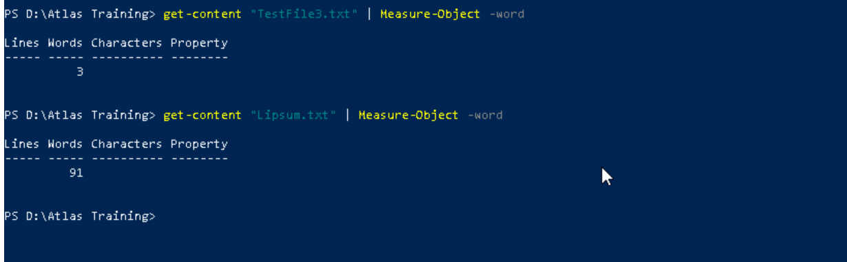

**What is the use of cat -b myfilename.txt command?**

It reads one or multiple files and prints their content to the terminal.

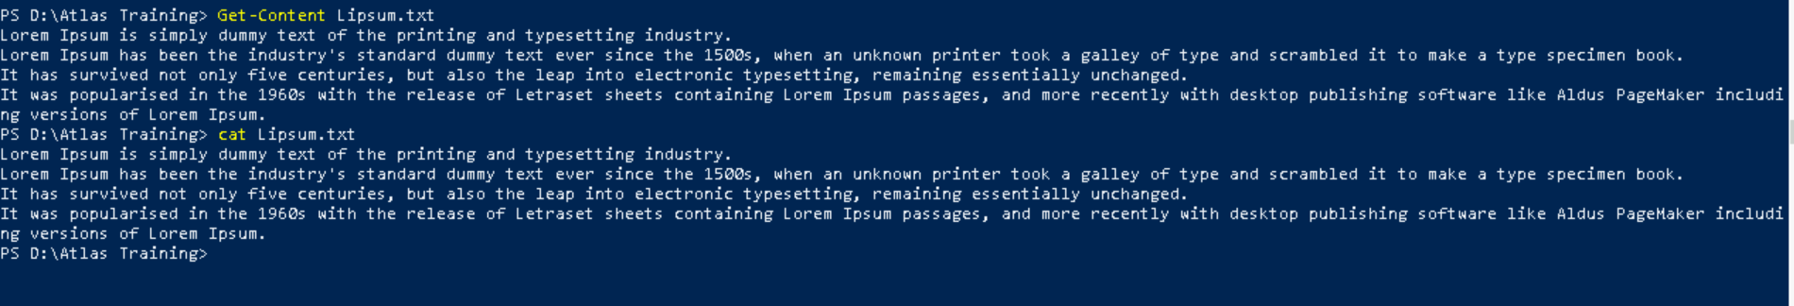

**Can I use the wc with 2 or more files?**

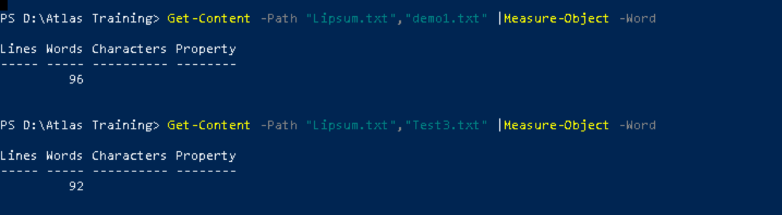

**How to copy content of one file to another file ?**

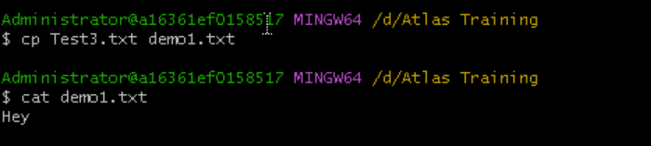

**Now I want to rename my file with MYFILENEW can i do that if so how ?**

**Hint use : mv**



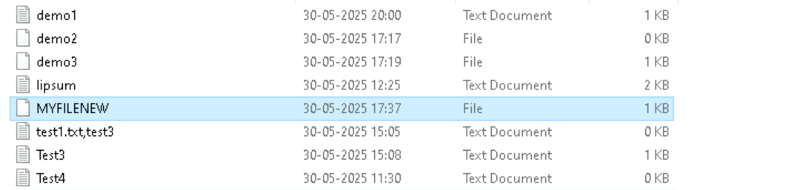

**Can i remove or delete multiple files in linux..? How?**

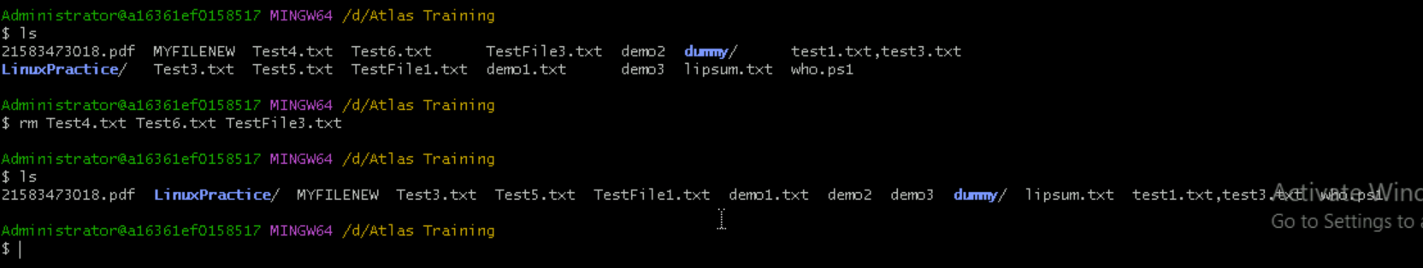

**In directory / slash is root … can you try cd / what is it doing?**



**What is the way go go to home directory ?**

**Hint : use cd ~**

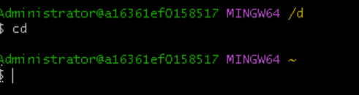

**If i want to move to different users home directory**

**Hint : use ~username**